Approximately 350,000 people visit Big Mountain Resort each year. The resort boasts 105 runs, 4 terrain parks, 11 lifts, 2 T-bars, and 1 magic carpet for novice skiers. Hellfire, the longest run, is 3.3 miles in length. The base elevation is 4,464 ft, and the summit is 6,817 ft with a vertical drop of 2,353 ft. Visitors get access to all of these features and more for a ticket price of $81.

Is this price consistent with ticket pricing for similar resorts within the market segment? This is what our team was tasked with answering.Our main goals were to determine how Big Mountain Resort could capitalize on its facilities to support raising ticket prices above the market average to increase revenue, and determine what features going forward they should invest in to continue this trend.

To start, we examined the data to get an overview of its contents, as well as to check its formatting and see if there were any missing or suspicious values. As we are looking for information on ticket prices, we removed all resort entries that did not include ticket prices. We updated values for a few incorrectly entered values, removed the weekday ticket price row as it had more missing values than the weekend ticket price, and added in columns to include state population information. Once we finished cleaning the data, we were left with 277 resorts that we could analyze.

To start our analysis, we looked at various features to determine trends, as well as where Big Mountain Resort sits within these features. We also looked to see if there were any patterns by state. We ran a principle component analysis which determined that the first two components account for over 75% of the variance, and the first four for over 95%. Graphing this on a scatter plot to include the average state ticket price, we saw there was no real pattern by state, meaning that we did not have to look at state specific data going forward. We could use the entire data set without it affecting our models. We then created a heatmap to see how each feature correlated with each other. This heat map indicated that the features most correlated to ticket price were the number of runs, number of fast quads, the vertical drop, area covered with snow making machines, and total chairs.

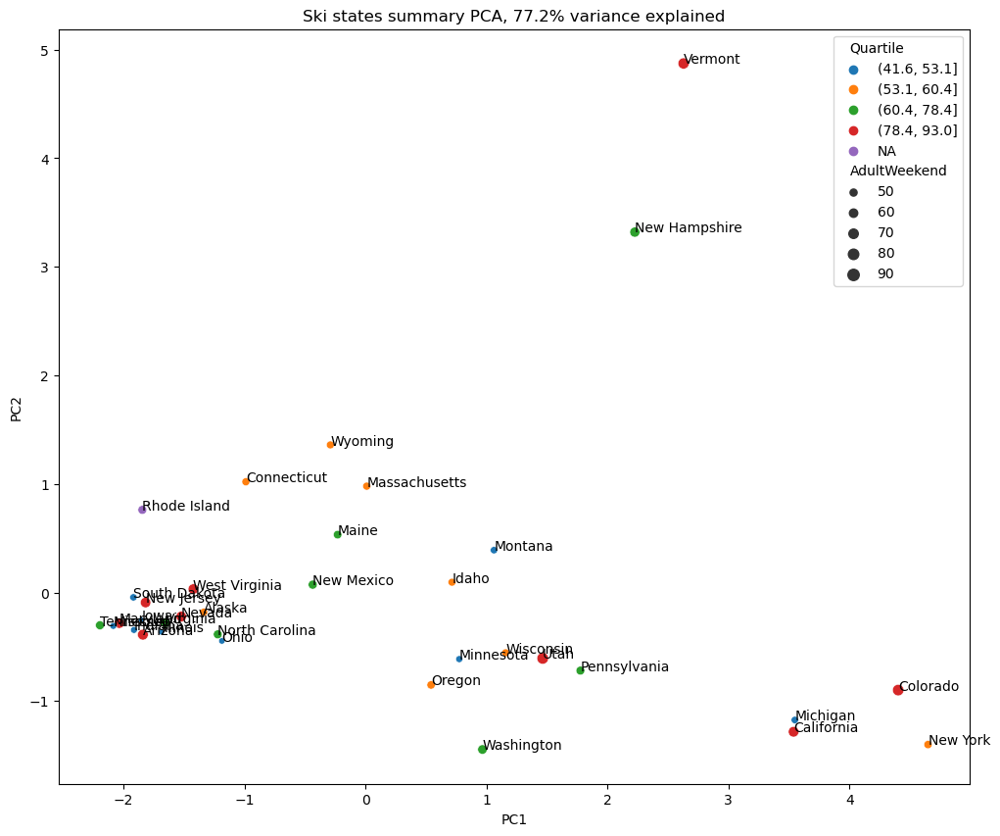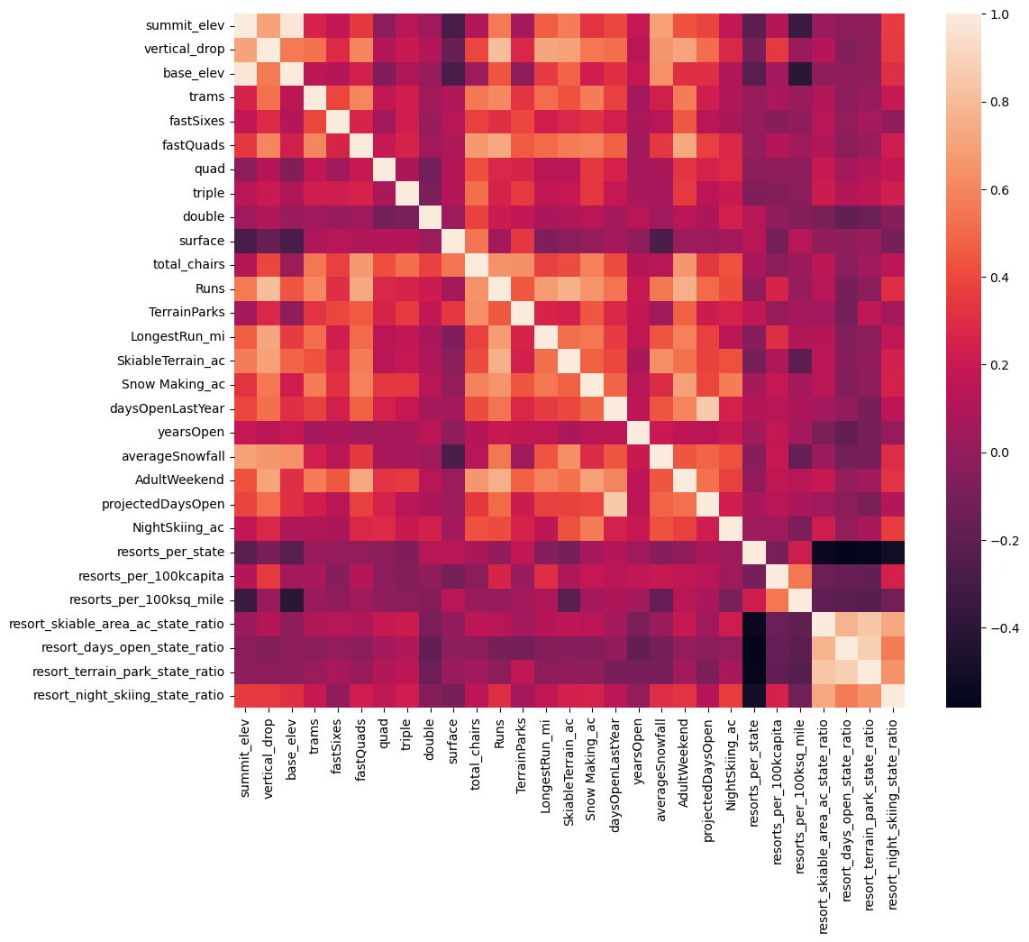

Once we completed our analysis, we began testing models. To begin, we separated the data into a 70% train/ 30% test split. We created a baseline using the average mean ticket price in order to compare future models against. The mean absolute error (MAE) for our baseline is approximately $19, meaning that if you guessed a ticket price based on the average of the known values, you can expect to be within $19. Once the baseline was established, we began working on models. The first model we tried was a linear regression. We imputed missing values based on both mean and median for each feature, and scaled the features of different orders of magnitude so they would be consistent. We refined the model further to select the best number of features to use in predicting ticket price, which was calculated at eight. We then tried a random forest model, again using the median feature values for imputing missing values. Both models show that the dominant features are the vertical drop, area covered with snow making machines, number of fast quads, and number of runs.

Running the models through cross-validation, they both performed better than the baseline. Between the two, the random forest regression model performed better. Its MAE of approximately 9.6 was $1 lower than the 10.4 from the linear regression model, meaning it was closer to estimating the correct ticket price. The random forest regression model also had a smaller standard deviation. Additionally, the random forest regression model was closer in consistency between the estimated performance and its performance on the test set. The Random forest regression estimated MAE at 9.6 and testing at 9.5, while the linear regression estimated the MAE at 10.4 and tested at 11.7.

Applying the random forest model to Big Mountain Resort, the price was predicted at $95.87, with an MAE of $10.39. Even if we take into account the extreme low end of the MAE, the predicted price is still at least $4 higher than the current price. Big Mountain Resort is towards the top of the pack in most features when compared to the rest of the marketplace, which suggests that we are undervaluing and underrepresenting our strength in the marketplace. And while Big Mountain resort does have the highest ticket price in the state, it also has more of the main features for which people are willing to pay more. For example, it is one of only two ski resorts in Montana that have any fast quads. The model demonstrates increasing the ticket price to at least $86, while also supporting an increase into the $90 range if we promote that we are on the high end of the popular features.

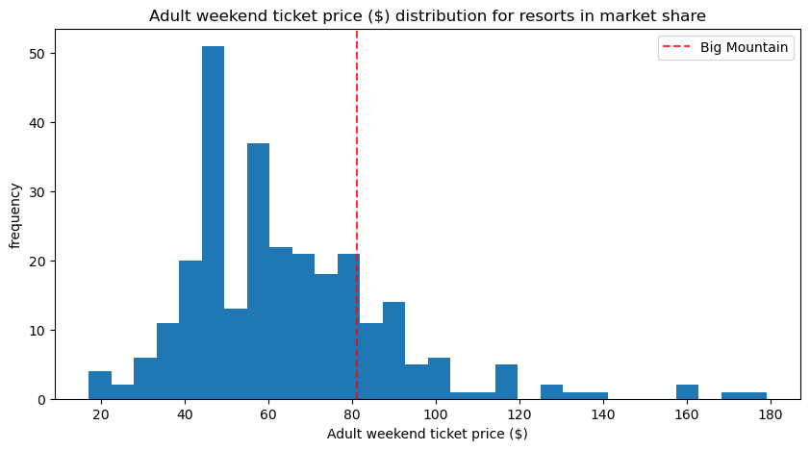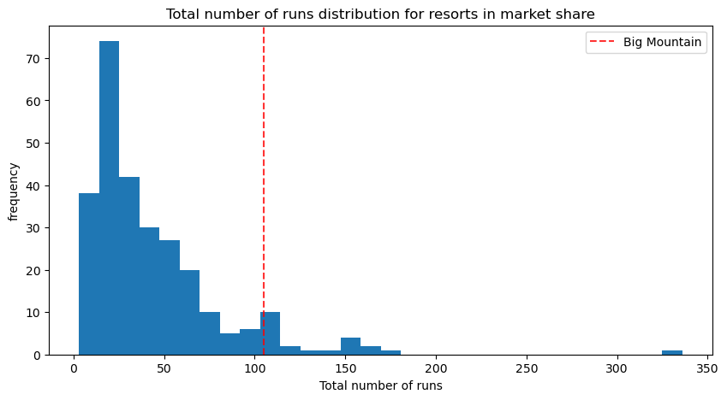

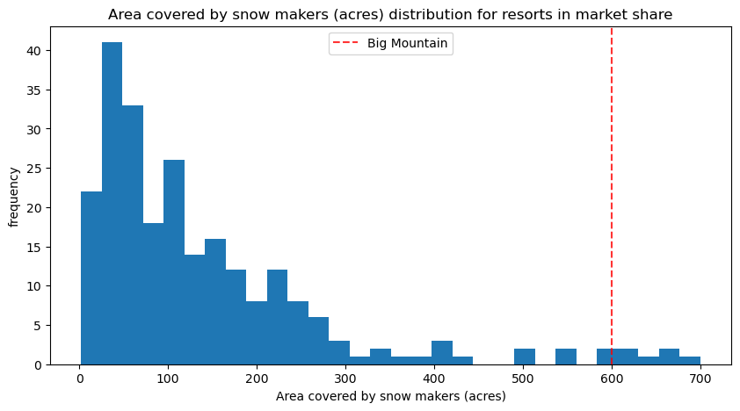

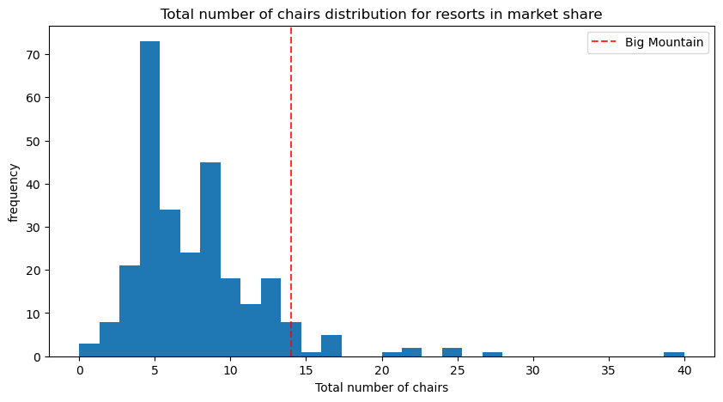

Based on the number of visitors expected and the number of tickets for each visitor, Big Mountain Resort will sell approximately 1,750,000. To cover the $1,540,000 increase in operational costs for the additional ski lift, we need to increase the individual ticket price by 88 cents. As the model suggests the ticket price should be significantly more than this, the resort will easily be able to recoup the cost of the additional lift.

Moving forward, Big Mountain Resort should continue investing in ways to increase the vertical drop, number of runs, and add more chairs. In addition, to possibly cut costs, they should start tracking operating and maintenance costs for the least used runs, to see if the reduction in costs outweighs the loss of revenue for closing some of the least used runs. Of the four shortlisted scenarios suggested for cutting costs and/or increasing revenue, the second option of adding another run and lift to increase the vertical drop is the most advantageous. Doing this supports a ticket price increase of $1.99, which equals a revenue increase of $3,474,638 per season.